**15 Basic Switch Configuration Commands Using Cisco Packet Tracer**

At First chose One pc and 1 switch model 2960 connect then through console cable.

1. **Navigating User Levels**

There are many navigating user level

Router> - User EXEC mode

Router# - Privileged EXEC mode

Router(config)# - Configuration mode (notice the # sign indicates this is accessible only at privileged EXEC mode)

Router(config-if)# - Interface level within configuration mode

Router(config-router)# - Routing engine level within configuration mode

Router(config-line)# - Line level (vty, tty, async) within configuration mode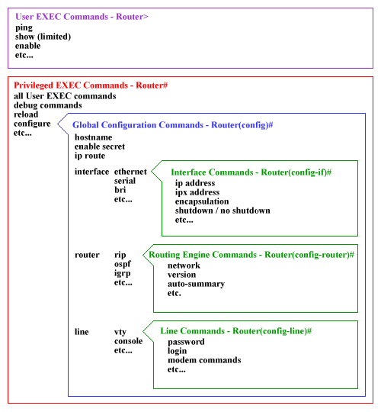

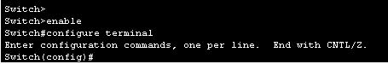

1. **Hostname**

To specify or modify the host name for the network server, use the **hostname** in global configuration command. The host name is used in prompts and default configuration filenames. The setup command facility also prompts for a host name at startup.

hostname ?

Syntax Description

|  |  |
| --- | --- |
| hostname | New host name for the network. |

Example:

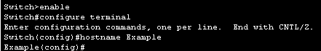

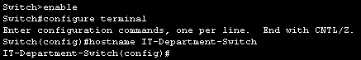

1. **Banner Motd/Message**

**MOTD Banner:**

the “message of the day” banner is presented to everyone that connects to the router / the message of the day banner that will be presented to anyone accessing the router.

Syntax Description

|  |  |
| --- | --- |
| banner motd # ? # | Name what you want to wirte inside # sign in global configuration mode |

Example

Here’s how to set a banner:

Router(config)#banner motd # This is the demo of MOTD banner #

You can also do multiple lines:

Router(config)# banner motd #

Enter TEXT message. End with the character '#'.

This is the demo of MOTD banner

Enjoy your stay

#

#**NOTE: - For delete**

Router(config)# no banner motd

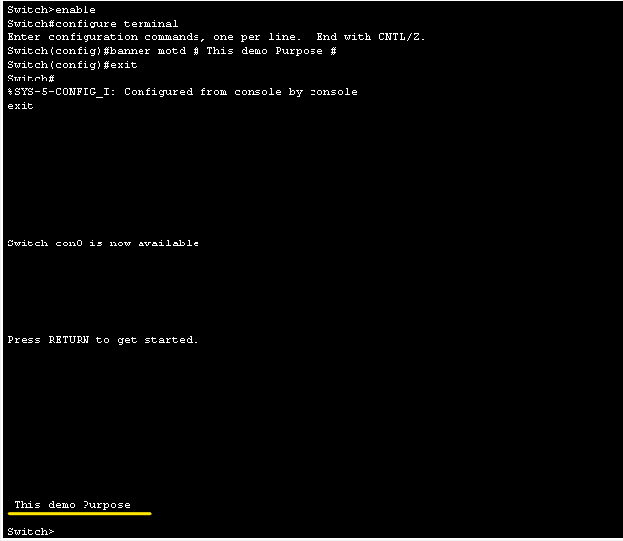

**Login banner:**

this one is displayed just before the authentication prompt / resented to users that access the router remotely using telnet or SSH:

Syntax Description

|  |  |
| --- | --- |
| banner login $ $ | Name what you want to write inside $ sign in global configuration mode |

Example

Here’s how to set a banner:

Router(config)#banner login $ This is the demo of Login banner $

You can also do multiple lines:

Router(config)# banner login $

Enter TEXT message. End with the character '$'.

This is the demo of Login banner

Enjoy your stay

$

#**NOTE: - For delete**

Router(config)#no banner login

**Exec banner:**

displayed before the user sees the exec prompt / specifies the message that is displayed after the user has logged in to the router. It is not displayed for reverse-telnet connections.

Syntax Description

|  |  |
| --- | --- |
| banner exec $ $ | Name what you want to write inside $ sign in global configuration mode |

Example

Here’s how to set a banner:

Router(config)#banner incoming $ This is the demo of EXEC banner $

You can also do multiple lines:

Router(config)# banner exec $

Enter TEXT message. End with the character '$'.

This is the demo of EXEC banner

Enjoy your stay

$

#**NOTE: - For delete**

Router(config)#no banner exec

**Incoming banner:**

used for users that connect through reverse telnet.

Syntax Description

|  |  |
| --- | --- |
| banner incoming $ $ | Name what you want to wirte inside $ sign in global configuration mode |

Example

Here’s how to set a banner:

Router(config)#banner incoming $ This is the demo of Incoming banner $

You can also do multiple lines:

Router(config)# banner incoming $

Enter TEXT message. End with the character '$'.

This is the demo of Incoming banner

Enjoy your stay

$

#**NOTE: - For delete**

Router(config)#no banner incoming

1. **Enable Password**

The enable password secures the privileged mode, which is required for all commands that change the router’s configuration / This password will not secure

Syntax Description

|  |  |
| --- | --- |
| enable password ? | After write cmd enable password then write what password what you want in global configuration mode |
| service password-encryption | Encrypts Passwords |

Example

Switch(config)#enable password cisco

Switch(config)#service password-encryption

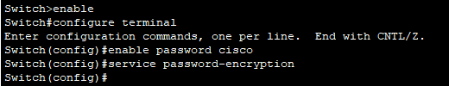

1. **Line Console Password**

In line console there will be password required to access User EXEC mode.

Syntax Description

|  |  |
| --- | --- |
| line console 0 | Line console meaning in the console cable login. |
| password ? | After password then write what password what you want in Global Configuration Mode |
| login | Enable password checking |
| service password-encryption | Encrypts Passwords |

Example

Switch(config)#line console 0

Switch(config-line)#password cisco

Switch(config-line)#login

Switch(config)#service password-encryption

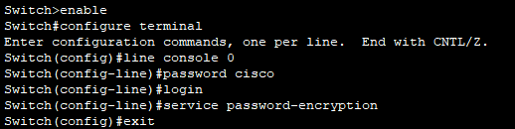

1. **Line VTY Password**

use telnet or SSH to access the switch they are accessing the vty lines and use the password configured on the vty.

Syntax Description

|  |  |
| --- | --- |
| line vty 0 15 | Virtual Teletype (VTY) lines indicate you can have 16 simultaneous connections |
| password ? | After password then write what password what you want in Global Configuration Mode |
| login | Enable password checking |
| service password-encryption | Encrypts Passwords |

Example

Switch(config)#line vty 0 15

Switch(config-line)#password cisco

Switch(config-line)#login

Switch(config)#service password-encryption

Switch(config-line)#end

Switch#wr

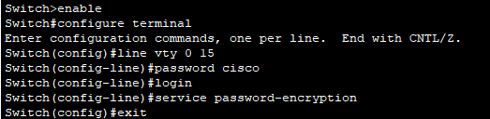

1. **Exec Timeout**

The Cisco “exec-timeout” command sets a specific time to disconnect idle EXEC sessions

Syntax Description

|  |  |
| --- | --- |
| exec-timeout minutes[00] seconds[00] | To enable ( Global Configuration Mode in config-line mode ) |
| logout-warning seconds | Warning before logout |

Example

Switch>enable

Switch#configure terminal

Switch(config)#line console 0

Switch(config-line)# exec-timeout 01 00

Switch(config-line)# exit

Switch(config)#line vty 0 4

Switch(config-line)#exec-timeout 01 00

**Logout-Warning**

Router(config)#line vty 0 4

Router(config-line)#exec-timeout 4 0

Router(config-line)#absolute-timeout 5

Router(config-line)#logout-warning 30

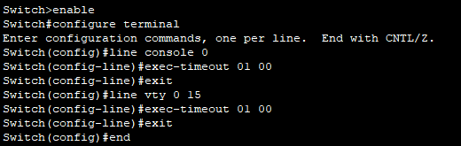

1. **Logging Synchronous**

This command controls the printing of log messages to a user’s terminal.

Syntax Description

|  |  |
| --- | --- |
| logging synchronous [level severity | all] [limit number-of-messages] | To enable (Global Configuration Mode in config-line mode) |
| no logging synchronous |  |

Example:

1. **IP Domain Name**

This command sets the domain name that the router will use to complete any unqualified domain names. See also ip domain-list.

Syntax Description

|  |  |
| --- | --- |
| ip domain-name domain | To Enable in Global Configuration Mode |
| no ip domain-name domain | To Disable in Global Configuration Mode |

Example:

Switch(config)#ip domain-name example.com

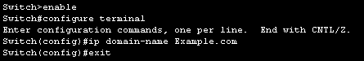

1. **Disabling IP Domain Lookup**

Syntax Description

|  |  |
| --- | --- |
| ip domain-lookup | To Enable in Global Configuration Mode |
| no ip domain-lookup | To Disable in Global Configuration Mode |

Example:

Switch(config)#ip domain-lookup

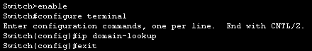

1. **Username and Password**

This is used for access the devices according to their username and password

Syntax Description

|  |  |
| --- | --- |
| username Name password ? | In name write a username and in ? sign write your password. |
| service password-encryption | Encrypts Passwords |

Example:

Switch(config)#username Example password CISCO

Switch(config)#service password-encryption

Or

Switch(config)#username example password cisco

Switch(config)#service password-encryption

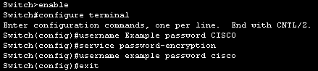

1. **Encrypting All Passwords**

To encrypt the all the password of the devices.

Syntax Description

|  |  |
| --- | --- |
| service password-encryption | Encrypts Passwords |

Example:

Switch(config)#service password-encryption

1. **Set Current Clock Time**

It is useful to set the router’s internal system clock to display the time in the local time zone.

Syntax Description

|  |  |
| --- | --- |
| clock set hr:mins:sec month day year | In hours it will be in 24hrs and set in Privileged EXEC mode |

Example:

Switch(config)#clock set 23:12:30 July 9 2024



1. **Set Management IP Address-SW**

Syntax Description

|  |  |
| --- | --- |
| interface valn 1 |  |
| no shutdown |  |
| ip address ip-address subnet |  |
| ip default-gateway ip-address |  |

Example:

Switch>enable

Switch#configure terminal

Switch(config)#interface vlan 1

Switch(config-if)#no shutdown

Switch(config-if)# ip address 192.168.1.254 255.255.255.0

Switch(config-if)#ip default-gateway 192.168.1.1

Switch(config-if)#exit

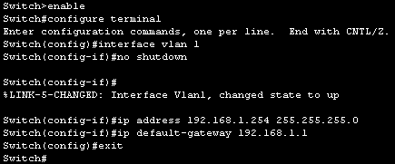

1. **Viewing Running & Startup Configs**

To view the current configuration of the devices.

Syntax Description

|  |  |
| --- | --- |
| do show running-configuration | In Global Configuration Mode |
| show running-configuration | In Privileged EXEC mode |

Example:

In Global Configuration Mode

Switch>enable

Switch#configure terminal

Switch(config)# do show running-configuration

In Privileged EXEC mode

Switch>enable

Switch#show running-configuration

1. **Saving Running into Startup Configs**

Syntax Description

|  |  |
| --- | --- |
| copy running-config startup-config | In Privileged EXEC mode |
| Wr | In Global Configuration Mode |
| do wr | In Privileged EXEC mode |

Example:

In Global Configuration Mode

Switch>enable

Switch#configure terminal

Switch(config)# do wr

In Privileged EXEC mode

Switch>enable

Switch#wr